Area and Perimeter 1
Write down the area and perimeter of these rectangles.
Area = _____cm²  Perimeter = ___cm  Area = _____cm²  Perimeter = ___cm | 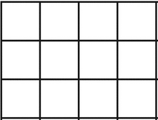  Area = _____cm²  Perimeter = ___cm  Area = _____cm²  Perimeter = ___cm

Area and Perimeter 2
Write down the area and perimeter of these rectangles.
Area = _____cm²  Perimeter = ___cm  Area = _____cm²  Perimeter = ___cm | Area = _____cm²  Perimeter = ___cm  Area = _____m²  Perimeter = ___m

Area and Perimeter 3
Write down the area and perimeter of these rectangles.
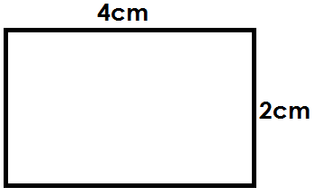  Area = _____cm²  Perimeter = ___cm  Area = _____cm²  Perimeter = ___cm | 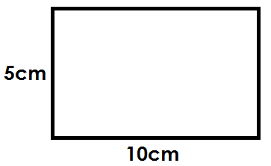  Area = _____cm²  Perimeter = ___cm  Area = _____m²  Perimeter = ___m

Area and Perimeter 4
Write down the area of the shaded triangles.
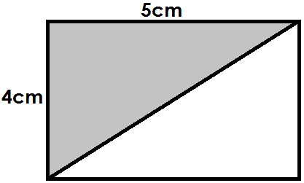  Area = _____cm²  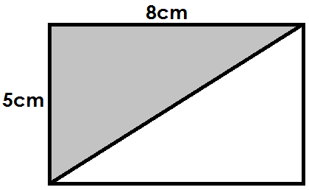  Area = _____cm² | 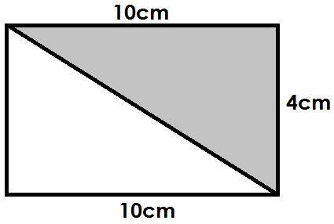  Area = _____cm²  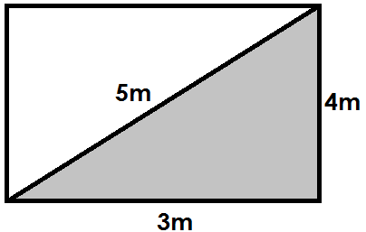  Area = _____m²  Perimeter = ___m

Area and Perimeter 5
Write down the area of the triangles.
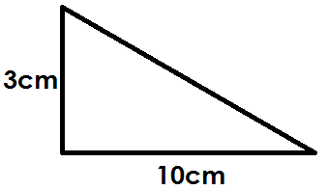  Area = _____cm²  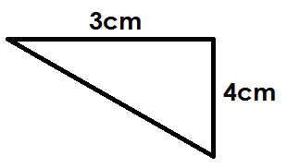  Area = _____cm² | 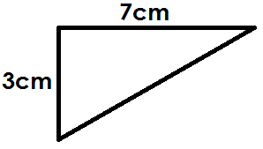  Area = _____cm²  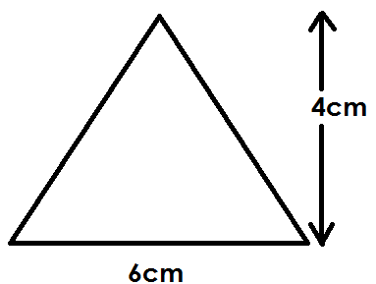  Area = _____cm²

Area and Perimeter 6
Write down the area of these shapes.
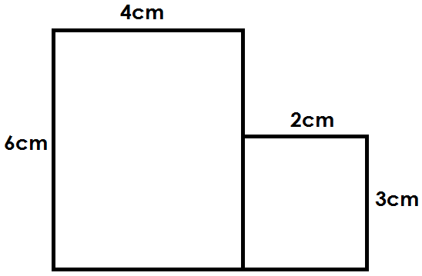  Total Area = _____cm²  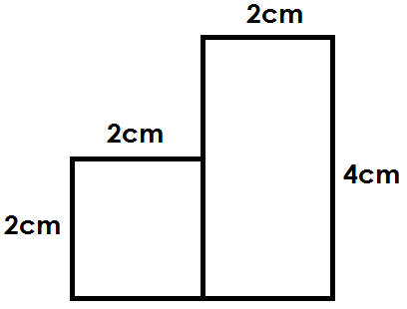  Total Area = _____cm² | 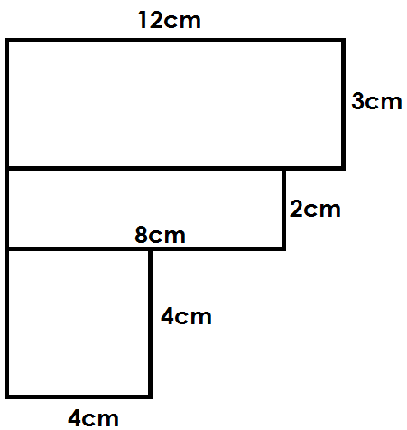  Total Area = _____cm²

